

TECHNICAL BUSINESS WRITING (TBW) FINAL PROJECT

Mam Abida Farid



ASJID TAHIR (P19-0085)

Muhammad Affan Khan (P19-00

Muhammad Zohaib (P19-

Jawad Ahmad (P19-

Umme Hani Javaid (P19-

Husni Ara (P19-

**CAFÉ AUTOMATION SYSTEM**

**Abstract:**

As we all know that today is a world of comfort. These days individuals don't have a lot of time to spend in bottle by there and trusting that the server will take their request. Numerous client visits the container in their lunch break so they have restricted opportunity to eat and get back to their individual office and universities. So this **Software** helps them to save time and request food at whatever point they need without calling the server again and again.

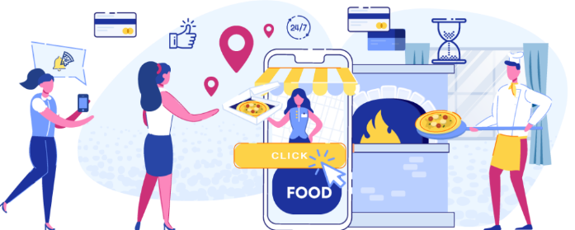This **Cafe Automation System** empowers the end clients to enlist on the web, read and select the food from **Menu Plan** and request food online simply by choosing the food that the client need to eat. The results after selecting the food from the menu plan will directly appear in the screen near the café who is going to cook the food for you. The system is the combination of Android as well as Web Application.

**Introduction:**

Computers have become part of the life for accessing almost any kind of information. Life in the 21st century is full of technological advancement and in this technological age it is very difficult for any organization to survive without utilizing technology. The World Wide Web contributes greatly to the creation of an ever-increasing global information database. It could also be used as a mechanism to share information within an enterprise. In the present period of fast food and take-out, many Cafe's have decided to zero in on fast arrangement and rapid conveyance of orders as opposed to offering a rich feasting experience Until very recently, all of these delivery orders were placed to the waiters or over the phone, but there are many disadvantages to this system, including the 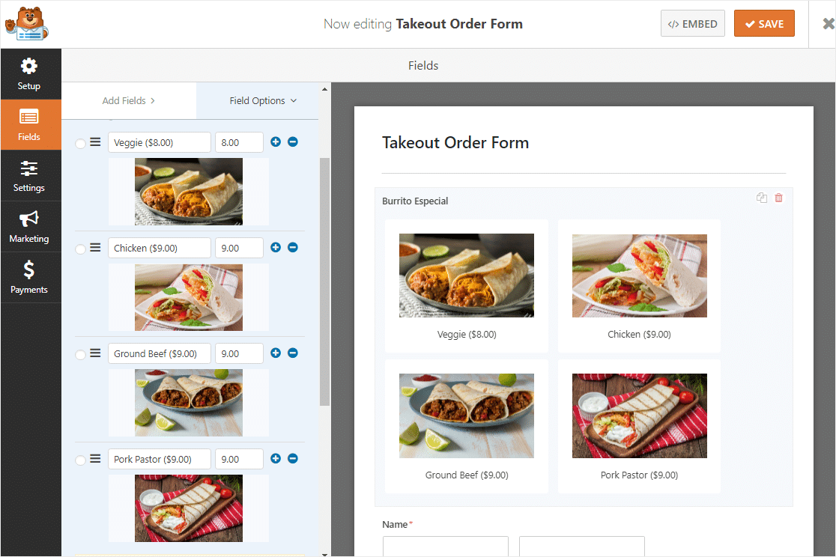inconvenience of the customer needing to have a physical copy of the menu, lack of a visual confirmation that the order was placed correctly, and the necessity for the canteen to have an employee answering the phone and taking orders. What, we propose is a Cafe Automation System, which is a technique of ordering foods **online** applicable in any food delivery industry.

The **benefit** of this framework is that it extraordinarily rearranges the ordering process for both the client and the Cafe member. At the point when the client visits the requesting page, they are given an interactive and up to date menu, complete with every accessible choice and powerfully changing costs dependent on the chose alternatives. After making a selection, the item is then added to their order, which the client can review the details of at any time before checking out.

This framework likewise significantly eases the burden on the container's

end, as the whole cycle of taking requests is automated. Once an order is placed on the webpage, it is entered into the database and then retrieved, in pretty much real-time, by a desktop application on the canteen’s end. Within this application, all items in the order are displayed, along with

their corresponding options and delivery details, in a concise and easy to read manner. This allows canteen employees to quickly go through the orders as they are placed and produce the necessary items with minimal delay and confusion.

**Objectives:**

Following are the objectives of this Café Automation system:

* 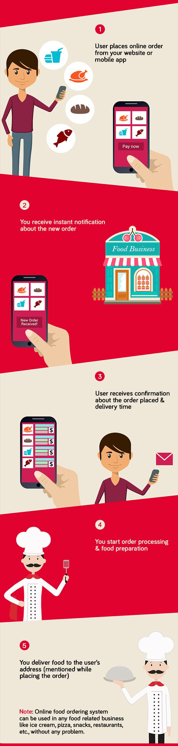Order Food Rapidly.
* To make it convenient for people who have limited time.
* Computerized Billing System.
* No Paper Works.
* Less expensive.
* Comfortable.

**Types of Users:**

* **Admin login:**
* Take order.
* Bill print.
* Add & Remove items in order.
* Add Offers.
* Sales for each day & month.
* Sales of individual item i.e. Sandwich,

Burger etc. for day.

* Total Earning.
* **Staff login:**
* Order placed by client.
* Order Forecasting.
* Offers.
* **User login:**
* Menu items.
* Place Order.
* Bill payment.

**Software Requirements:**

* Windows 7 or higher.
* Android Development Toolkit.
* Android 4.0 or higher.
* SQL Server.

**Hardware Requirements:**

* i3 processor based computer.
* Ram (1gb).
* Hard Drive (50gb).
* Internet Connection (24/7).

**Systematic Diagram:**

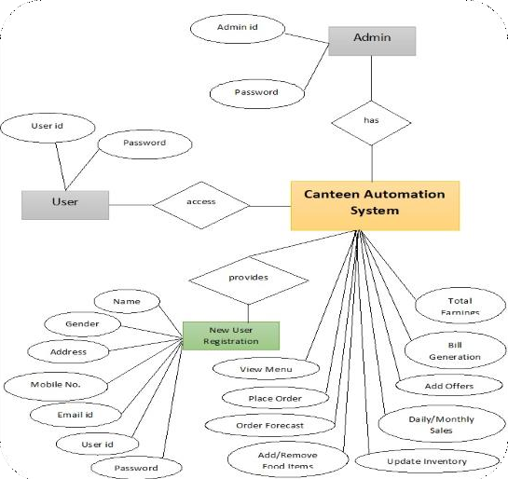

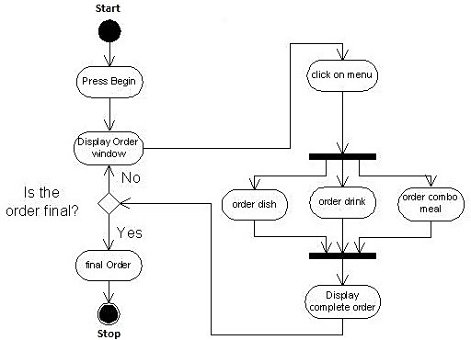**ACTIVITY DIAGRAM:**

**Advantages:**

* Completely automated online ordering of food in a Cafe.
* Order can be placed using personal android phones from any place.
* Food ordering pages that look and feel exactly the same as the existing restaurant website.
* User can also order a Special Combo Box which contains multiple food items.
* Food ordering pages hosted on secure and special server so no risk of customers getting redirected to servers where competitors' websites are listed.
* Single and individual Admin Panel and login for each Canteen.
* Detailed summary of orders placed with option to search orders, update order status, print orders, etc.
* Various reports to view total sales, details of registered members with facility to print report.
* Easy to use for client.

**Disadvantages:**

* Requires an active internet connection.
* Requires Android phone if user is ordering.

**Application Use:**

* Restaurants.
* Canteens.
* Bakeries.
* Cafeterias.

**Features:**

* **Easy accessibility:**

Records can be easily store and accessible.

* **User Friendly:**

Very user friendly approach for all users.